ELEC 3EY4 – Lab 5

Objective 2

Activity 4
What is a node in ROS?
- A node in ROS is a point/program where data is communicated to other points in a system through a publish/subscribe messaging mode. This model allows multiple nodes in a system to interact with one another
- Nodes can be on different types of systems and architecture, which makes ROS extremely flexible to the needs of the user
- These messages posted by a node are exchanged between one another through a topic connecting them (basically a line)

Activity 5
Briefly explain the role of each node launched by “simulator.launch” and relate them to their corresponding blocks in Fig. 1
- /behavior_controller: Corresponds to the "Behavior Controller" block. This node determines the source of the vehicle's drive commands. It subscribes to inputs from the joystick and keyboard and publishes a selector signal to the /mux topic, deciding whether the manual input or an autonomous planner controls the vehicle.
- /f1tenth_simulator: Corresponds to the "Simulator" block. This is the core node that models the vehicle's dynamics and kinematics. It subscribes to the /drive topic for velocity and steering commands and publishes simulated sensor data, including LiDAR scans (/scan), IMU data, and wheel odometry (/odom).
- /joy_node: This node interfaces directly with the Logitech F710 joystick hardware. It reads the state of the joystick's buttons and axes and publishes this raw data as a sensor_msgs/Joy message on the /joy topic.
- /keyboard: This node captures keyboard input from the user and publishes it, allowing keyboard-based control of the vehicle.
- /map_server: This node provides static map data to the simulator or other nodes that might need it for tasks like localization or path planning.
- /mux_controller and /random_walker: These correspond to potential "New Planner" blocks. The random_walker is a simple autonomous planner that publishes random drive commands. The mux_controller likely manages the multiplexing of these commands based on the behavior controller's signal.
- rviz: While not a ROS node but a ROS tool, RViz is launched to visualize the simulator's output. It subscribes to topics like /scan, /odom, and /map to provide a graphical representation of the vehicle and its environment, corresponding to the "Visualization" aspect of the simulation.

Activity 6
Based on your computation graphs, what topics are published by the “/f1tenth_simulator” node? And What topics are the node subscribed to? Comment on the update rates of various topics in the computation graph and the factors that could influence these rates. Briefly explain the role of topics in ROS.

Using rqt_graph, we captured the ROS computation graph under different display settings. These graphs illustrate the communication between nodes via topics.
Computation Graph - Nodes/Topics (Active):
Computation Graph - Nodes/Topics (All) :

Based on the computation graphs, specifically the "Nodes/Topics (all)" view, the following observations were made:
- Topics published by /f1tenth_simulator: The node publishes to /odom (odometry data), /scan (simulated LiDAR data), and likely /tf (coordinate transforms).
- Topics subscribed to by /f1tenth_simulator: The node subscribes to the /drive topic, which provides the Ackermann steering commands.
- Update Rates: The rqt_graph shows update rates for topics, such as /drive at ~20 Hz and /scan at a rate dependent on the simulator's configuration. The rate of /drive is determined by the publishing node (e.g., random_walker or joy_node after processing). The rate of /scan is influenced by the simulator's physics update rate and the simulated LiDAR's scan time, as set by the update_pose_rate parameter.
- Role of Topics: Topics in ROS are named buses over which nodes exchange messages. They provide a decoupled, anonymous communication layer. A publisher node sends data to a topic without knowing who, if anyone, is subscribing. Subscriber nodes listen to a topic without knowing who the publisher is. This allows for modular and flexible system design.

Activity 7
Which node publishes to the “/drive” topic and at what rate? Which fields of the “/drive” topic are updated and what do they represent? Provide your answers in your written report.

The /drive topic was examined using the rostopic command-line tools:
$ rostopic info /drive

This command revealed that the node publishing to /drive is /random_walker when the simulator is launched in its default state. However, when manual driving is enabled by pressing the LB button, the /mux node passes through joystick commands, and the publisher effectively becomes the joystick input processed by the behavior controller.
The rate of the /drive topic was measured using rostopic hz /drive.
Rate of the /drive Topic:
$ rostopic echo /drive
- Echoing the topic while driving the vehicle showed that the following fields are updated:
- header.stamp: The timestamp of the command.
- drive.steering_angle: The desired steering angle for the virtual front wheel (in radians). This value changes as the joystick's horizontal axis is moved.
- drive.speed: The desired linear velocity of the vehicle (in m/s). This value changes as the joystick's vertical axis is moved.
- The acceleration and jerk fields were not populated in this default configuration.

Activity 8
discuss the various modes of motor control (e.g., speed, torque, etc.) and comment on their suitability for use in electrical vehicles in manual and self-driving modes.
Electric motors, particularly those controlled by a VESC, can operate in several modes:
- Speed (or Velocity) Mode: The controller attempts to maintain a commanded speed (RPM or m/s) regardless of the load torque, up to its power limit. This is highly suitable for both manual and autonomous driving as it provides a predictable and stable response to the driver's or planner's commands.
- Torque (or Current) Mode: The controller applies a commanded torque (current) to the motor. This mode is more fundamental and can offer faster dynamics. However, it is less intuitive for manual driving, as the vehicle's speed would vary with terrain. In autonomous driving, it requires a higher-level controller to manage speed, making it more complex but potentially more efficient.
- Duty Cycle (or Voltage) Mode: This is an open-loop mode where a fixed PWM duty cycle is applied. It is the simplest but offers the least control, as motor speed is highly dependent on load and battery voltage. It is generally unsuitable for precision applications like autonomous driving.
For this project, Speed Mode is the most suitable. It provides a direct interface to the high-level planner that outputs a desired speed in m/s, abstracting away the low-level current/torque control. This simplifies the control stack and ensures consistent vehicle behavior.

Activity 9
The steps to create the experiment node were followed meticulously:
- experiment.cpp was created and populated with the provided code.
- The file permissions were set to executable.
- The <run_depend>vesc_driver</run_depend> dependency was added to package.xml.
- The VESC messages were copied to the simulator's include directory.
- The package was rebuilt with catkin_make.
- experiment.launch was created with the provided content.
This activity was completed and demonstrated to the TA.

Activity 10
Explain the purpose of the following two functions in the file “experiment.cpp”. In the function “laser_callback()”, do you anticipate a potential issue arising depending on whether the number of data points in a single scan is even or odd number? Explain. Modify the code to address this potential bug. Include the modified code as part of your lab submission.

For publish_driver_command()
- This function essentially limits how quickly both the steering angle and motor speed can change
- If we are too aggressive with the rate at which the steering angle and motor speed changes, we can get jolts/jittery movement of the AEV which is what we saw during the lab
- On the other hand, if we allow the steering or speed to jump instantly, we could also get unstable driving as a sudden steering movement or speed change would put unnecessary stress on its components and would make the bot harder control
- max_delta_servo and max_delta_rpm both limit how fast their corresponding value changes by clipping the desired angle/rpm if it’s bigger than the maximum angle/rpm
- The function then publishes the smoothed-out signals (instead of one where the values would go up and down aggressively) to the corresponding ROS topic

For laser_callback()
- This function rotates the scan by 180 so that the angle is flipped (ex. front scan becomes back) so that the raw data is aligned with the AEV’s forward direction
- As the RPLIDAR runs in boost mode (returns 720 readings in one scan), we divide by 2 to get a range of 360 (n1)
- The for loop uses matrix notation to modify each element by + n1 (which essentially is a 180 degree rotation)
- The function then publishes the messages onto the corresponding ROS topic

If we had an odd number for n1, when divided by 2 and ran in the loop, we would have an extra element that would never get rotated at the end (we would index up until the 2nd last element as the int data type would round down to the closest whole number), which means the scan would be slightly off.

Instead of essentially “splitting” the ranges and rotating the halves, we can manually move every element by calculating the appropriate shift, and then using a modulus operator to ensure we stay within the index

void laser_callback(const sensor_msgs::LaserScan & msg) {
int n1 = msg.ranges.size();
int shift = n1/2;
std::vector<float> scan_ranges=msg.ranges;
std::vector<float> scan_intensities=msg.intensities;
for (int i=0;i<n1;i++){
scan_ranges[i]=msg.ranges[((i + shift) % n1)];
scan_intensities[i]=msg.intensities[((i + shift) % n1)];
}

Activity 11
The params.yaml file was updated with safe limits: max_speed: 1.0 and max_steering_angle: 0.41. The Logitech F710 joystick was set to 'X' mode. With the vehicle safely on foam blocks, the experiment was launched using roslaunch f1tenth_simulator experiment.launch. Pressing the LB button successfully enabled manual control via the joystick's analog sticks. This was demonstrated to the TA.

Activity 12
Report the ROS topics associated with the VESC ROS driver. Examine the rate at which the motor speed and the servo steering angle commands are published to their respective topics. What is the rate of execution for the VSEC driver node “/vesc_driver_node”? What factors affect these rates? (you can use the command rostopic list). Your findings should be included in your written report.
- After using rostopic list, we can see the topics we are interested in specifically are the ones that control speed (commands/motor/speed) and position (commands/servo/positon)
- We can subscribe to these topics and find their publishing rate through rostopic hz
- For speed we have an average rate of 75.051 Hz, and for position we have an average of 75.215 Hz
- The rate of execution for the VESC driver node is around 1.5 ms or 667 Hz

Within our experiements.cpp file, we defined parameters (ex. ros::Duration) that control how often a command is run, which sets the corresponding rate at which the following functions that call upon it are published.

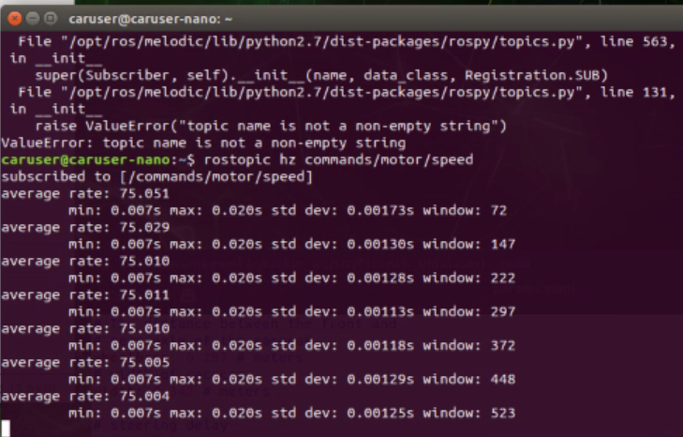Figure A: Rate of Speed Topic | 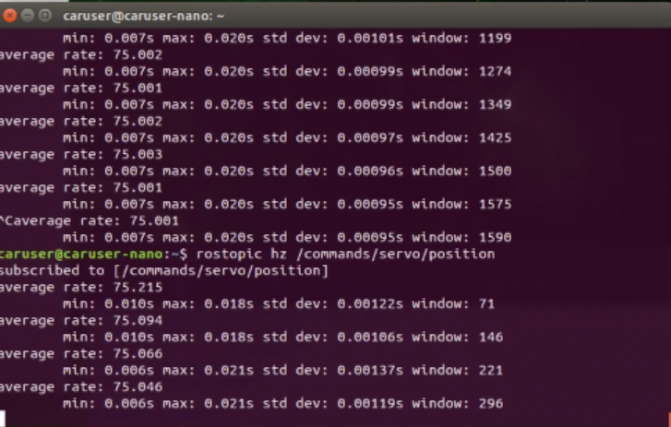Figure B: Rate of Position Topic

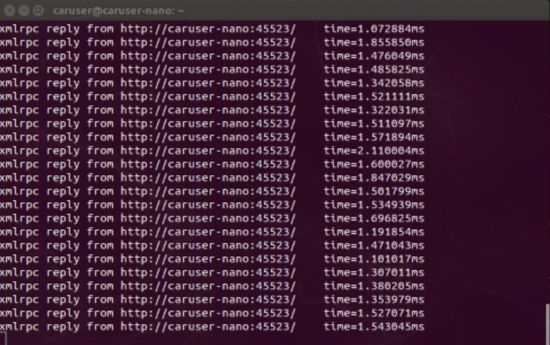
Figure C: Rate of VESC Driver Node

Activity 13
Derive the expression in (2) for k_{w}. Include your derivations in the report.
$$w_{m}=rotational velocity of mechanical motor$$
$$w_{e}=rotational velocity of electric motor$$
$$w_{w}=rotaional velocity of wheel$$
$$ω_{e, erpm}=k_{w}v_{s}$$
$$ω_{w}=\frac{v_{s}}{r_{w}}$$
$$ω_{m}=g_{r}ω_{w}$$
$$ω_{e}=\frac{p}{2}ω_{m}$$
$$ω_{e}=\frac{p}{2}g_{r}ω_{w}$$
$$ω_{{e, rad}/s}=\frac{p}{2}g_{r}\frac{v_{s}}{r_{w}}$$
$$ω_{e, erpm}=\frac{p}{2}g_{r}\frac{v_{s}}{r_{w}}\frac{60}{2π}$$
$$k_{w}v_{s}=\frac{p}{2}g_{r}\frac{v_{s}}{r_{w}}\frac{60}{2π}$$
$$k_{w}=\frac{15g_{r}p}{πr_{w}}$$

Activity 14
The gain offset was determined to be 0.4900

Activity 15
$2r=150 cm$ -> $r=75 cm$
$$δ_{d}=0.4189$$
$$\overline{k_{δ}}=-0.88$$

Activity 16
Use the results of calibration experiment to re-calculate the value of k_delta. Update the value of this parameter in “params.yaml”. Include your calculations in your report.
$$l=29cm$$
$$δ=\tan^{-1}\left(\frac{29}{75}\right)$$
$$δ=0.369 rad$$
$$k_{δ}=\frac{δ_{d}}{δ}\overline{k_{δ}}$$
$$k_{δ}=\frac{0.4189}{0.369}\left(-0.88\right)=-0.999$$
The recalibrated gain value was determined to be –0.999.

Activity 17
Examine the following line from the file “experiment.cpp” and explain what it does:
update_command = n.createTimer(ros::Duration(1.0/driver_smoother_rate), &RacecarExperiment::publish_driver_command, this);
Include your observation and answer in your report.
- ros::Duration(1.0/driver_smoother_rate) sets the timer's period. It creates a Duration object equal to the inverse of driver_smoother_rate. If driver_smoother_rate is 50, the period is 0.02 seconds (20ms).
- &RacecarExperiment::publish_driver_command is a pointer to the member function that should be called each time the timer expires.
- this is the pointer to the current RacecarExperiment object instance, required for the callback to be called correctly.
- this line configures a timer that will call the publish_driver_command function at a fixed frequency of driver_smoother_rate Hz. The rostopic hz /commands/motor/speed command showed an average rate of ~75 Hz, which directly corresponds to the value of driver_smoother_rate used (likely 75), confirming that this timer governs the rate at which motor and servo commands are sent to the VESC.

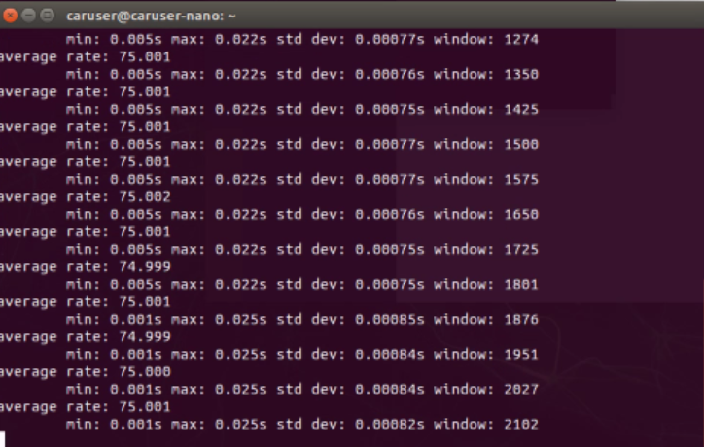

Activity 18
provide one use case for each of the following ROS commands based on the activities of this lab:
$ rosrun
This command is used to run a ROS package’s executable/ set of instructions.
Ex: rosrun rqt_graph rqt_graph
In this lab, rosrun was used to run the rqt_graph plug-in from the rqt_graph package. This opened a graph showing all the active nodes and the topics through which they communicate.
$ roslaunch
This command is used to launch multiple nodes simultaneously, and set parameters on the Parameter Server.
Ex: roslaunch f1tenth_simulator simulator.launch
In this lab, roslaunch was used to run simulator.launch from the f1tenth_simulator package. This ran many nodes that allowed the joystick to control a simulated version of the car. It also ran rviz which created a visual of the simulated car.
$ rosnode
This command is used to display requested information about ROS nodes. It can also be used to kill a specified node.
During debugging in Activity 6, we could use rosnode list to see all actively running nodes, confirming that essential nodes like /f1tenth_simulator, /behavior_controller, and /joy_node were operational. Additionally, if a node failed to start properly, we could use rosnode ping /node_name to check if it was responsive, or rosnode info /node_name to examine its connections, subscribed topics, and published topics, which helped verify that the communication structure matched the expected computation graph.
After launching the simulator, we could have used rosnode list to see all running nodes, confirming that /f1tenth_simulator, /joy_node, and others were active. rosnode info /f1tenth_simulator would have provided detailed information about its connections, services, and subscriptions.
$ rostopic
This command is used display requested information about ROS topics.
Ex: rostopic info /drive
In this lab, rostopic info /drive was used to determine the desired steering angle, which is a field in the topic /drive. This was used to re-calibrate the steering of the car by modifying the steering gain.

